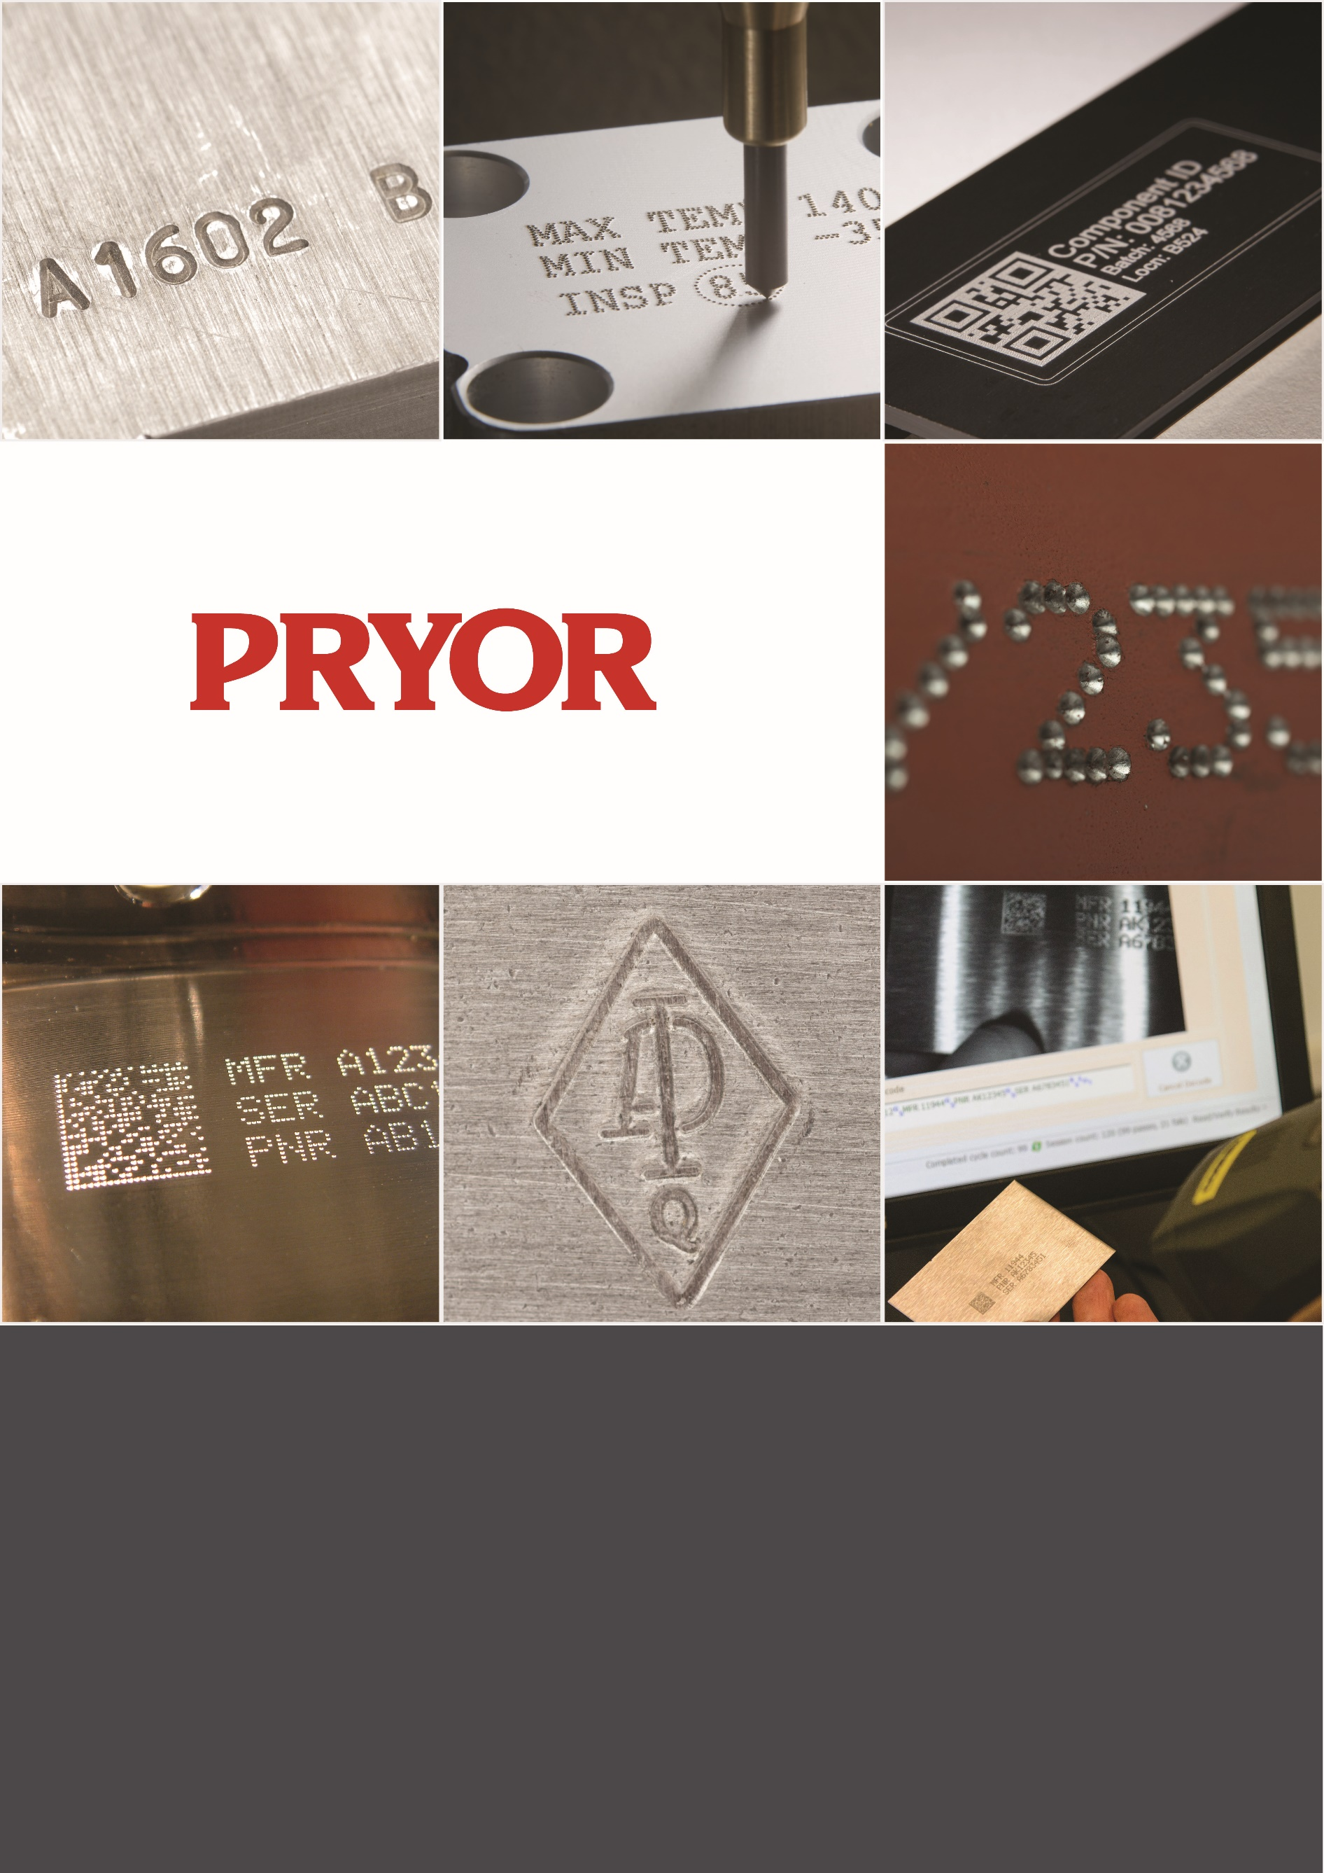

Getinge Imnstrument Marking Solution
Laser Marking User Guide

Table of contents

1. System Start Up 3
2. GMS Fluid marking process 8
3. Marking Layout 10
Contact Us 12

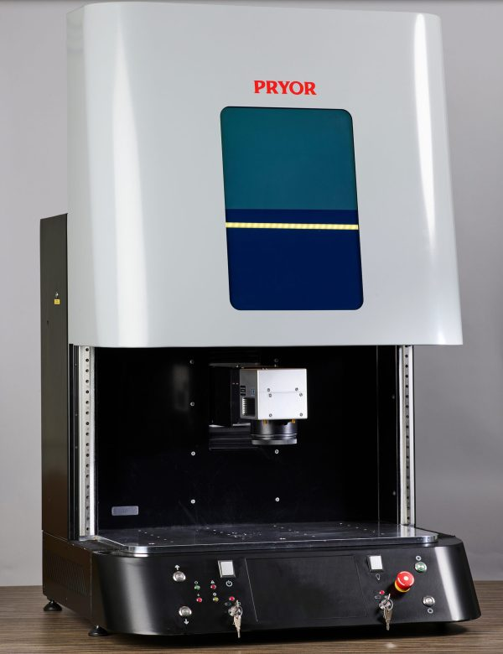

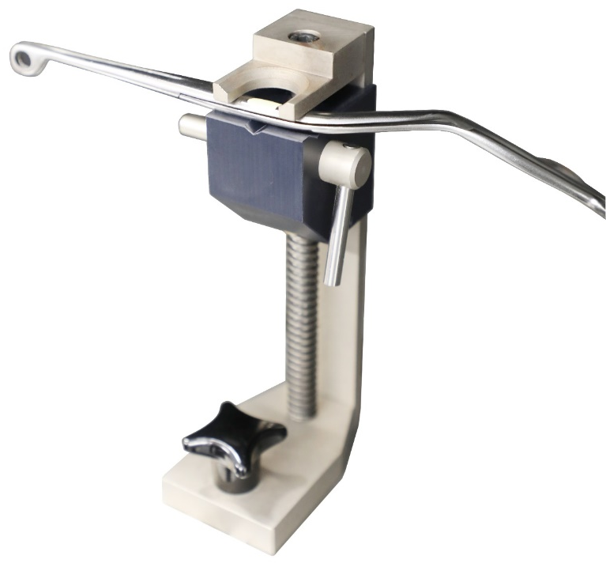

1. System Start Up
Plug the USB cable at the rear of the GMS into the port labelled ”USB”. Connect the other end of the USB cable into an available USB port on the PC or Laptop. Power up the laser first by switching on the power switch on the front panel. Insert the laser power and shutter override keys and turn clockwise.
Switch on the laser controller PC by pressing the power button on its front panel. A Blue indicator light will appear. The controller will start up quickly and display the familiar desk top display.
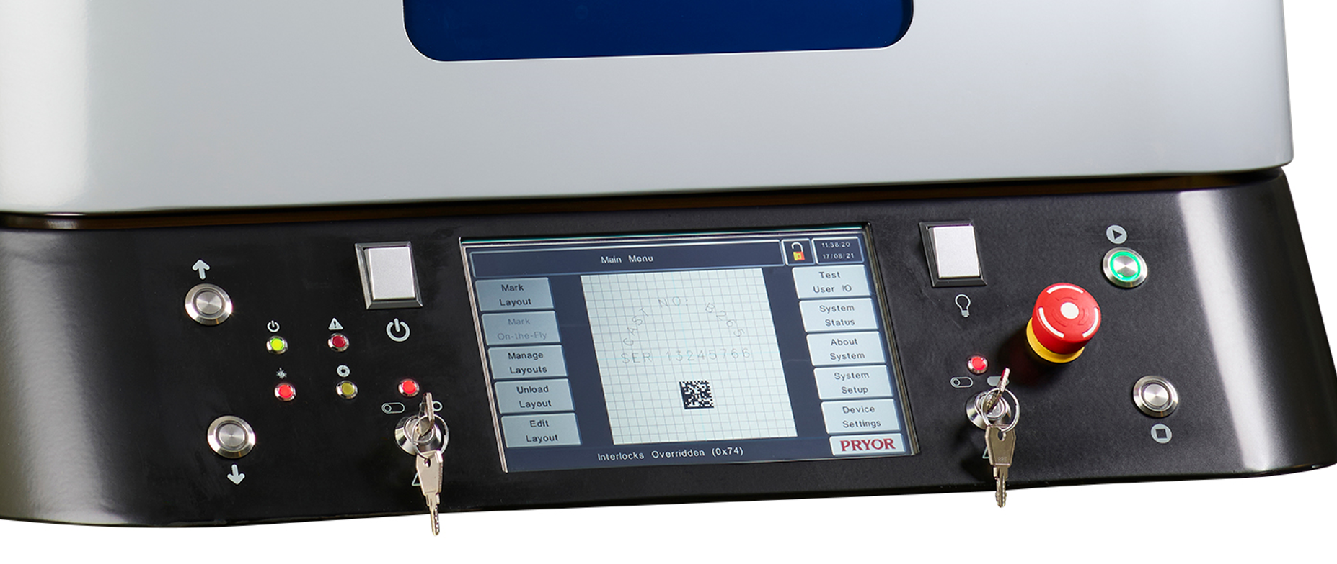
Double click on the Mark Master icon on the desktop to start the laser control software.  The Master Mark logo will briefly appear to show that the software is loading successfully. |  | 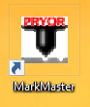
The Marking Devices Available screen will now be displayed. Initially, this will display the message that a device has not been found, whilst the PC and the laser make a connection. Sometimes this can take a few moments.
When the link is established, the message will turn white and display the message “Fiber laser found” and display a list of the most recently marked layouts. |  | 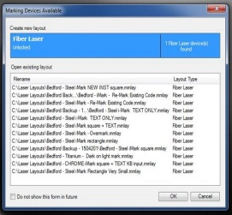
The PC will start connecting to the laser as shown by the message in the bottom left of the screen
When successful, the ’Connecting to Laser’ message will change to a ’Laser Connected’ message in the bottom left hand corner of the MarkMaster display

In MarkMaster, open the appropriate Marking program by clicking on the OPEN FILE icon and select an appropriate layout depending upon the material being marked:
Stainless Steel GIMS square  The vast majority of instruments are stainless steel and this layout is used for marking new instruments only | 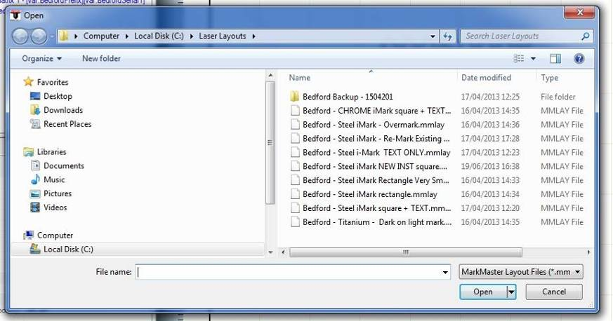
Titanium – Dark on Light
This produces a dark mark on a bright background patch on blue or black titanium instruments
CHROME GIMS square
This is for chrome plated instruments which will not mark with the Stainless Steel settings
Double click on the layout required and it will be loaded into Mark Master and will appear on the main screen
A detailed description of these layouts is in section 3. Marking Layouts | 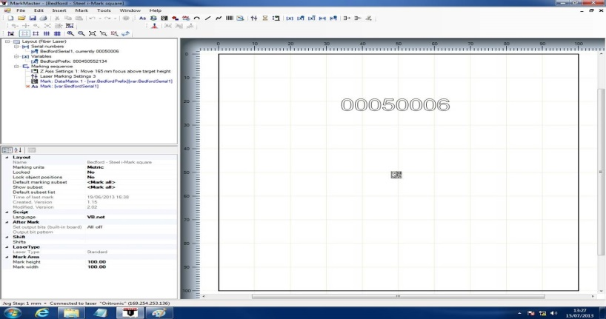
More than one layout can be held in MarkMaster at one time and can be quickly changed by selecting the window menu from the very top line of the screen and then selecting from the list of the loaded layouts that appears in the drop-down list | 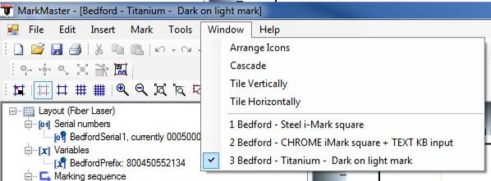

When the layout has loaded, click on the Data Matrix symbol so that the red Handle appears: | 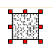
Then click on the Outline Tool to show each location where the mark will be made by using the red visible target laser: | 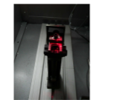
The first time that either Outline or Mark mode are selected, the laser will ask to “Home” the Z Axis. Click YES and the laser will move the automatic focus head to its correct position.  This only happens at initial power on and is not needed again during production. | 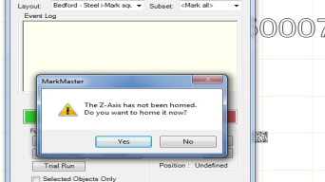
Click on the Outline tool again to exit outline Mode, then click on the Mark Mode button, close the cabinet door then click on the green start button to mark the instrument.
The red light on the laser control panel will be illuminated during the marking which will only take a few seconds.  When the green panel light comes on, the marking is complete and it is OK to open the cabinet door and unload the instrument. | 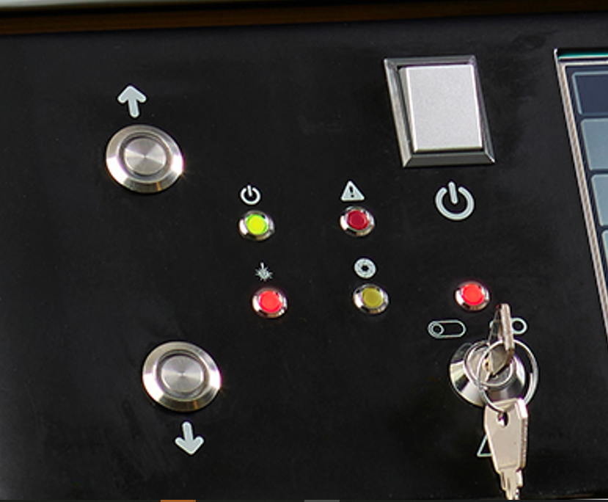
The Marking control display will show the time taken to mark the Instrument. | 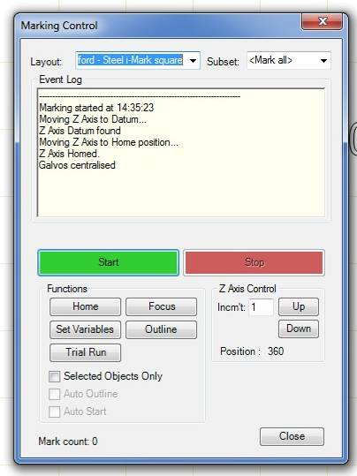
There is also an outline button on the Marking control display and clicking on this button will also show the location of the mark and can be used to align the next instrument without having to select another display. | 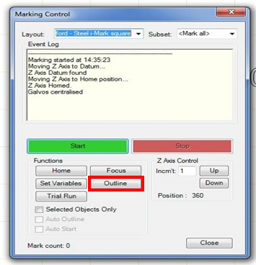
The green Start and red Stop buttons on the making control display perform the same functions as the green and red illuminated buttons on the Laser front panel.

2. GMS Fluid marking process

- Clean the area to be marked on the instrument with an alcohol wipe to remove any residues.  [The discarding of the wipe must follow your Disposal of Hazardous Waste process.]  Allow to dry. | 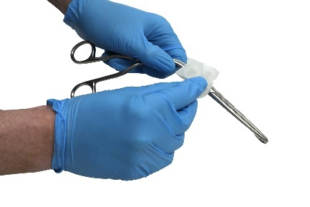
- Thoroughly shake the GMS fluid until you can hear the ball bearing rattling inside the bottle (note, this may take up to 1 minute of vigorous shaking if the fluid has been left for some time).  Also ensure that no sediment is at the bottom of the bottle before application. | 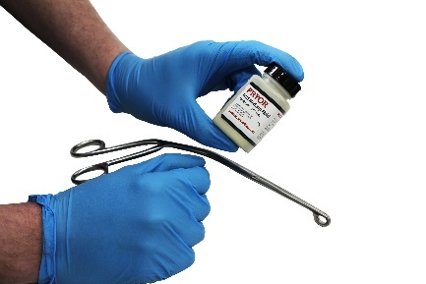
- Apply a thin, even coat of the GMS fluid using the small paint brush provided inside the lid and reseal bottle. Allow to thoroughly dry, which is indicated by the surface turning from a gloss to a matt finish | 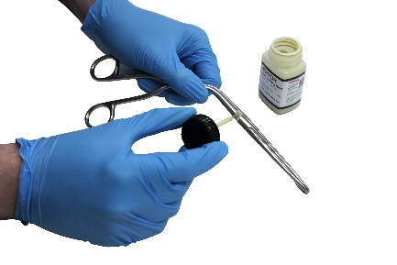
- Place the instrument into the gripper, taking care not to damage the coated surface.  Select and run the appropriate MarkMaster template in line with the laser instruction manual. The laser will fuse the dried medium to the metal beneath, making the mark permanent.  Remove the instrument from the gripper. | 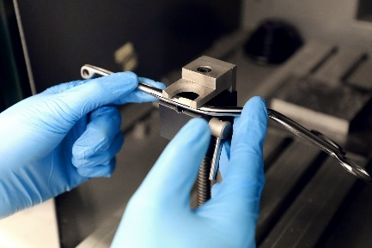
Clean off the excess GMS fluid which has not been bonded to the instrument, by wiping it off with a detergent wipe.  [The discarding of the wipe must follow your Disposal of Hazardous Waste process.] | 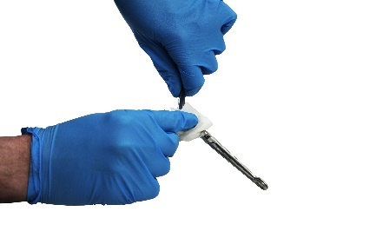
- Record the instrument description and GS1 serial number onto the instrument tracking system as appropriate.

- Return the instrument to be washed.

Return to step 1 for subsequent instruments.

3. Marking Layout
Titanium – Dark on light mark  Layout for blue or black instruments only  The layout first creates a bright patch on the instrument by gently removing the blue coating over a small area.  It then marks the GS1 code with a dark mark in the center of the bright patch.  Extensive testing has confirmed that this method of marking is safe, durable and easier to read than the previous technique of a light mark on the blue surface.  The layout automatically uses the next available GS1 serial number to mark the instruments. | 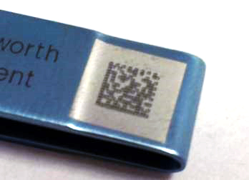
 | 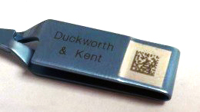
 | 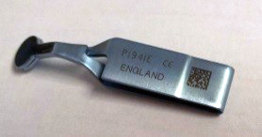

CHROME GIMS laser mark plus text –  re-Marking existing code  Chrome is a coating usually plated onto brass which conducts heat more quickly than stainless steel. For this reason, a slightly more powerful laser setting is needed when marking Chrome otherwise a faint mark will result. | 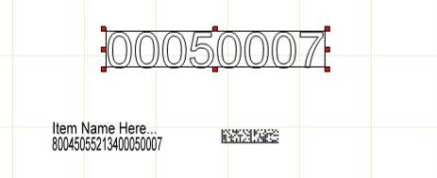  The text can be typed in when the request dialogue box is displayed.  This layout has the option for the GS1 code and some text to be marked in readable form alongside the 2D Data matrix code:
In other respects it should be marked in the same way as stainless steel using the GIMS laser marking process. This layout must not be used on stainless steel instruments.

Chrome is no longer commonly used for instruments, however dental syringes and some dilators are examples of instruments made from chrome. It is not always easy to distinguish chrome from very highly polished stainless steel. Some people consider chrome to have a bluish tint, while stainless steel is greyer, but this is often only apparent when they are compared side by side.

If these extra items are not required, they are to be temporarily disabled by clicking next the appropriate line in the layout listing on the left of the screen. This will display a red cross to indicate the instruction has been turn off. It can be tuned back on when required by simply clicking on the cross itself: | 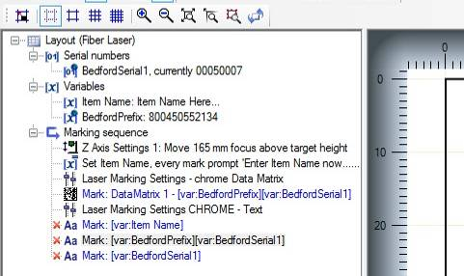
End of Document

Contact Us

Pryor is a global leader in providing traceability, identification and data capture
technologies. A supplier of high quality, permanent marking equipment for full
traceability in the supply workflow. Pryor solutions offer permanent, non-destructive marking of components and instruments to improve efficiency and accountability, by ensuring full control of your traceability.

Pryor UK  www.pryormarking.com  Sheffield, S1 4JX  +44 (0) 114 2766044  info@pryormarking.com | Pryor France  www.pryortechnologie.fr  91140 Villebon-sur-Yvette  +33 (0) 1 69 28 50 45  info@pryortechnologie.fr | Pryor USA  www.pryortechnology.com  Ashland, VA  +1 (804) 4966669  sales@pryortechnology.com

GMS Surgical Instrument Marking Solution
Improving efficiency and accountability in the sterile supply workflow
https://www.pryormarking.com/products/GMSSurgicalInstrumentMarkingSolution
https://www.pryormarking.com/products/gms-marking-fluid
The GMS Surgical Instrument Marking Solution is sold in collaboration between Pryor and Getinge. Contact Pryor to find your local GMS Surgical Instrument Marking
Solution sales office.

PRYOR World leading identification tools, designed and manufactured in the UK since 1849

www.pryormarking.com
