Surgical Instrument Marking Solution
Improving efficiency and accountability in the sterile supply workflow

www.pryormarking.com

» Fast and accurate
» Permanent, high contrast mark
» Non-destructive laser with bonded marking fluid
» Mark GS1 2D Data Matrix, alphanumeric codes and logos
» Easy to use, pre-programmed marking layouts
» Bench top system installed on-site

Surgical Instrument Marking Solution

Ensure full traceability in your sterile supply workflow

The Surgical Instrument Marking Solution provides high quality and accurate laser marking for full traceability in your sterile supply workflow.

Mark instruments in different sizes
Single instruments come in a wide range of shapes and sizes, especially in ophthalmology and pediatrics, where small, delicate
instruments are common. Pryor’s laser technology gives you the flexibility to mark instruments of almost any size – even ultra-slim instruments.
Staff can use a simple hand-held barcode scanner to log the uniquely identified instrument in the hospital’s asset management system, for complete visibility of the sterile supply workflow.

The solution offers permanent, non-destructive and high-quality marking of surgical instruments, improving efficiency and accountability in the sterile supply workflow by ensuring full control of your traceability.

Sterile supply management and traceability

Marking inconsistencies across different materials can lead to errors in the sterile supply workflow.
Traceability software provides fully integrated templates that help reduce the risk of human errors and ensure a consistent high-quality marking.

The intuitive interface supports a smooth and fast marking process and reduces the need for
time-consuming training, as staff at all skill levels are able to operate the device.

Fast and easy instrument marking

The Surgical Instrument Marking Solution offers a fast and easy way of marking surgical instruments. Conventional marks are usually around 4x4mm in size and take about
9 to 10 seconds to mark. The highlighted marks are slightly larger and take approximately 15 to 16 seconds to mark.

The actual marking process is by far the fastest stage in the production process. However, with organising, loading and unloading items the average time per mark is about 90 seconds. The Surgical Instrument Marking Solution laser beam does not touch the surface of the stainless steel, hence the passive layer is unaffected. This allows instruments to be returned to the wash immediately after marking without the risk of corrosion.

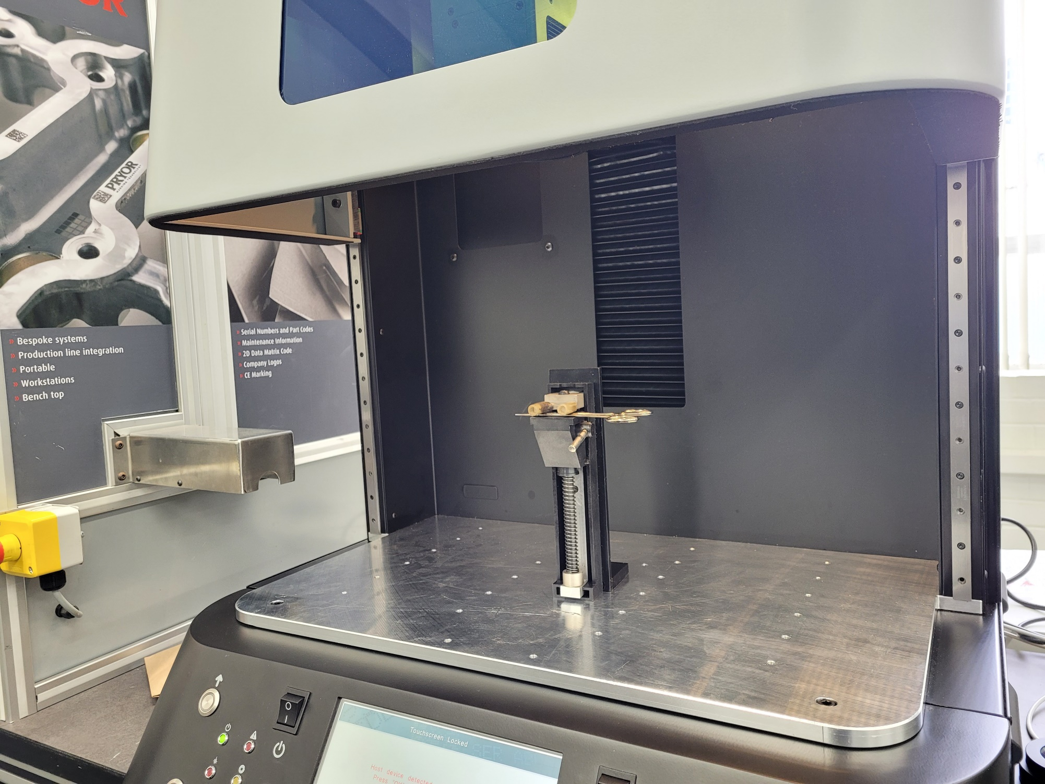
Enhance patient safety and confidence

With high-quality marking of instruments, the hospital staff are able to trace instruments every step of the way, and patients can be confident in the quality of the instruments used in their care.
» Easy-to-use software to control the marking process
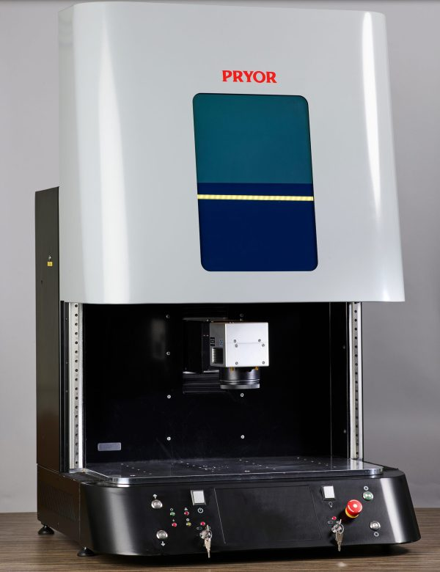
» Advanced Data Matrix marking specifically for surgical instruments
» Precise visible beam targeting for accurate mark placement
» Angle and arc text marking
» Variable date input features
» Laser setting control for instrument grade materials
» Range of flexible marking options - either using True Type fonts, drawing/shape tools or graphics/logo in HPGL/ DXF format

Conventional or highlighted Data Matrix marking

The Surgical Instrument Marking Solution uses GS1 2D Data Matrix which provides the unique identifier that enables users to access all relevant data quickly and faultlessly on use, maintenance, and manufacturer from the instrument management system.

Highlighted marks greatly enhance the readability of codes on small highly curved polished items such as drills and probes. The GS1 2D Data Matrix thus improves workflow efficiencies and enhance productivity by reducing the time spent looking for the instrument code during production.
Option 1 Option 2

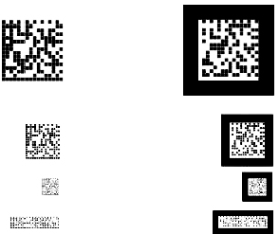
The Surgical Instrument Marking Solution, delivers durable, high-contrast marks for
best-in-class readability and enhanced Data Matrix visibility to speed up the scanning and packing processes. Two marking options are available, conventional or highlighted markings. Highlighted marks are outlined with a black square around the GS1 2D Data Matrix to improve workflow efficiencies and enhance productivity by reducing the time spent looking for the instrument code during production.

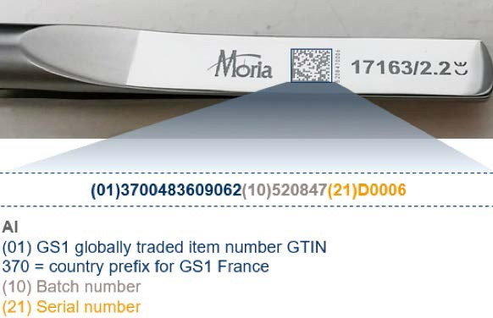
The International Global Coding Standards Organisation

GS1 is the International Global Coding Standards Organization. GS1 has developed identification systems that enable an instrument to be traced back to its source from anywhere in the world.

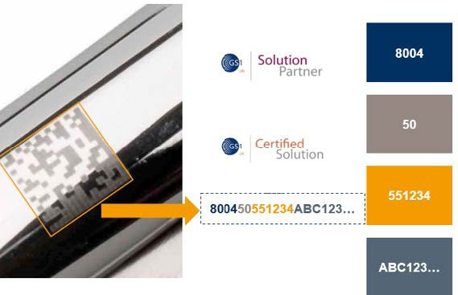
GS1 is dedicated to the design and implementation of global standards and solutions to improve the efficiency and visibility of supply and demand across sectors globally. The GS1 system of standards is the most widely used supply chain system in the world.

Pryor is a global leader in providing traceability, identification and data capture technologies. A supplier of high quality, permanent marking equipment for full
traceability in the supply workflow. Pryor solutions offer permanent, non-destructive marking of components and instruments to improve efficiency and accountability,
by ensuring full control of your traceability.

Pryor UK
www.pryormarking.com Sheffield, S1 4JX
+44 (0) 114 2766044

info@pryormarking.com

Pryor France
www.pryortechnologie.fr 91140 Villebon-sur-Yvette
+33 (0) 1 69 28 50 45

info@pryortechnologie.fr

Pryor USA
www.pryortechnology.com Ashland, VA
+1 (804) 4966669

sales@pryortechnology.com

Surgical Instrument Marking Solution
Improving efficiency and accountability in the sterile supply workflow

https://machines.pryormarking.com/product/surgical-instrument-marking-solution/
The Surgical Instrument Marking Solution is sold in collaboration between Pryor and Getinge. Contact Pryor to find your local Surgical Instrument Marking
Solution sales office.

PRYOR World leading identification tools, designed and manufactured in the UK since 1849

www.pryormarking.com

