Surgical Instrument Marking Solution, Technical Specification

27th March 2023

– Equipment Description

Overview

The Pryor Bench Laser is a bench mounted laser engraving machine. Laser engraving, otherwise known as laser etching or laser marking, offers a non-contact form of permanent marking. It is the fastest and most versatile marking system and is therefore suitable to high volume and high variety output. Laser engraving provides excellent precision on a wide range of materials.

- Non contact marking
- Permanent marking
- Fast and versatile
- Suitable for high volume and high variety

Features

- Automatic Vertical Opening Door
- Large internal working envelope
- Automatic Z axis for focussing/defocusing on target component
- Large laser safe viewing window
- Integrated touch screen controls, using our innovative 4000 controller interface
- Optional PC interface using Traceable-IT software for advanced programming and programme creation
- Exceptional reliability. Fit and forget performance with diode life exceeding 50,000 hrs
- Maintenance free marking with no consumable costs.
- High quality marking on a wide range of materials including metals / alloys and hard plastics.
- Low running costs, fibre lasers consume less than 200watts of power, making these lasers the most efficient on the market. (1.06 micron wavelength)
- Wide operating temperatures between 0 and 42°C
- Industry leading Traceable-IT software
- Available in a range of class 1 enclosures
- Also available as an integration package. The compact size and robust construction make the YF lasers the perfect solution for automated part marking tasks.
- Intelligent laser controller can operate in a basic standalone mode or using the built in TCP/IP connectivity can connect to a local or remote PC for advanced operation using the Traceable-IT graphical interface.
- Visible ‘Pilot’ beam shows the marking location for fast, accurate setup.
- Secondary (converging) ‘focus finder’ visible beam shows when the laser is focused.
- Robust, easy to use control panel features high quality start/stop/focus finder push buttons with built in emergency stop and key-switch safety interlock control.

Design

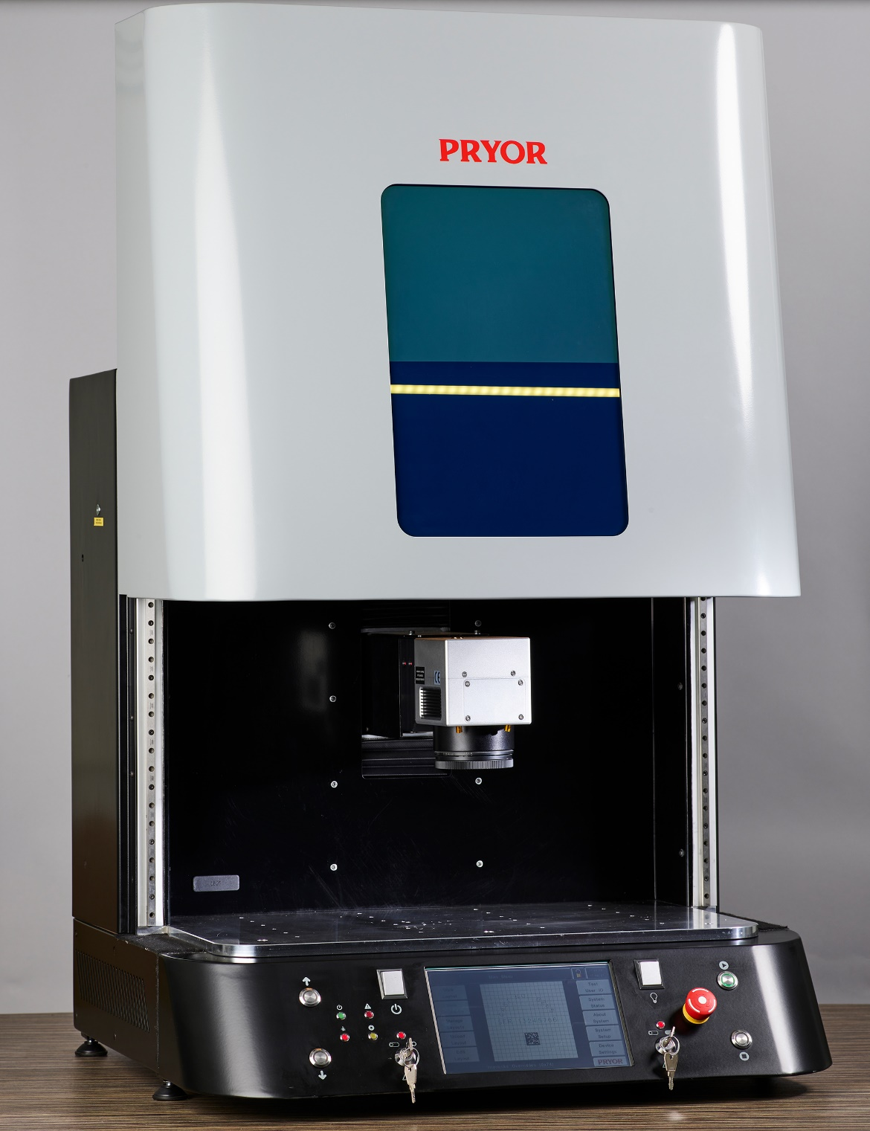

Dimensions

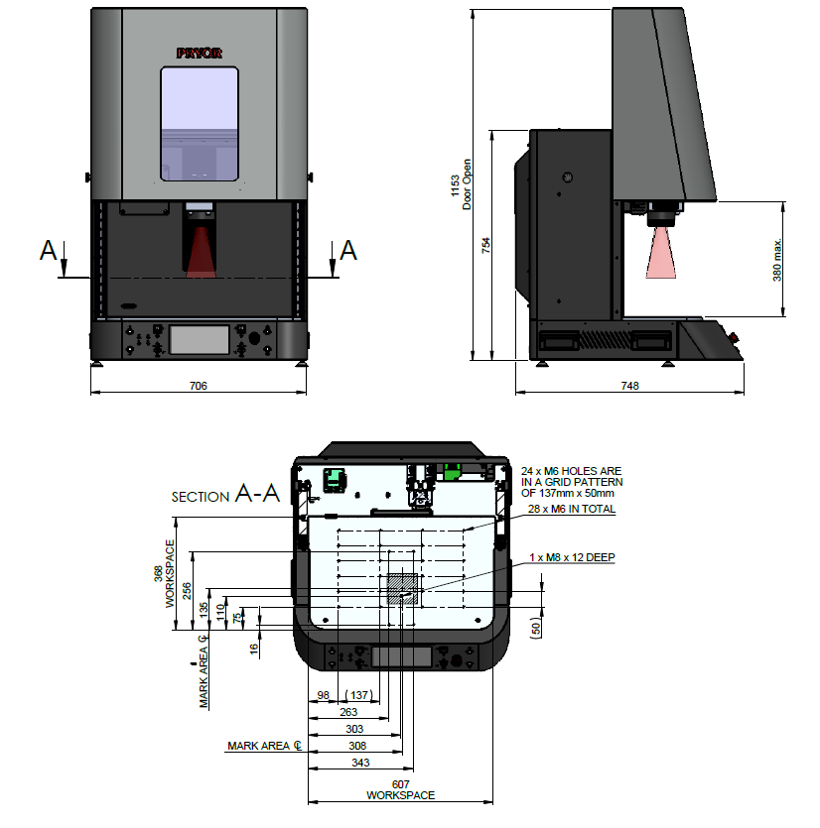

Laser Specifications

Specification
Model | Pryor Surgical Instrument Solution
Power | 20W
Laser Type | Fibre Laser
Marking Area | 100mm x 100mm
Pulse Energy | 1mJ
Average Power | 20W
Msquared | 1.6
Polarization | Random
Power Tunibility | 5 – 100%
Pulse Duration @ 20KHz | 100ns
Repetition Rate | 20 KHz to 200KHz
Long Term Power Stability | 1-3%
Operating Temperature | 0 to 42°C
Cooling | Active Air Cooling
Fibre Optic | 2 Meter Pigtail With 8mm Collimator/Isolator
Power | Less Than 200W - 110 or 220 VAC
Machine Weight | 78Kg
Product Warranty | 2 years as standard

No installation, commissioning or training is included in the above breakdown, as this is assumed to be conducted by Mecagrav staff.

